Index | Color | Class (Fruit)
1 | Red | Apple
2 | Red | Apple
3 | Green | Apple
4 | Green | Banana
5 | Green | Apple
6 | Orange | Banana
7 | Orange | Banana
8 | Orange | Apple
9 | Yellow | Banana
10 | Yellow | Banana
Distribution check

Red (2 points): A, A
Green (3 points): A, B, A
Orange (3 points): B, B, A
Yellow (2 points): B, B

Label Encoding X =Color = Red =1, Green=2 , Orange=3, Yellow=4

Index | Color | Class (Fruit)
1 | 1 | Apple
2 | 1 | Apple
3 | 2 | Apple
4 | 2 | Banana
5 | 2 | Apple
6 | 3 | Banana
7 | 3 | Banana
8 | 3 | Apple
9 | 4 | Banana
10 | 4 | Banana
x=1: A, A (2 points)
x=2: A, B, A (3 points)
x=3: B, B, A (3 points)
x=4: B, B (2 points)

For Simplicity A=Apple and B= Banana

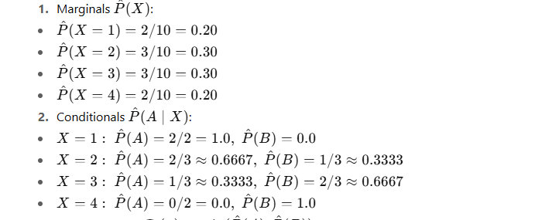

P (Bayes Error) = 1 - Highest Error Probability

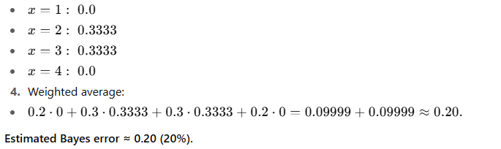

(Interpretation: even the perfect Bayes classifier — if trained on the true distribution — would misclassify on average ~20% of examples.)

Example-2

Color (X) | Fruit (Y)
Red (1) | A (Apple)
Red (1) | A (Apple)
Green (2) | A (Apple)
Green (2) | B (Banana)
Orange (3) | B (Banana)
Yellow (4) | B (Banana)
Here:
A = Apple
B = Banana
X = Color encoded as numbers (1=Red, 2=Green, 3=Orange, 4=Yellow)

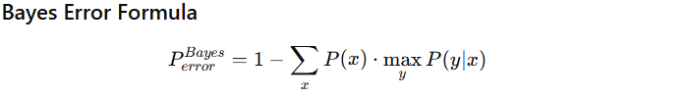

Prior probabilities of color

Each color appears once except Red and Green.
P(Red=1) = 2/6
P(Green=2) = 2/6
P(Orange=3) = 1/6
P(Yellow=4) = 1/6

Conditional probabilities

For Red (1): Both are Apple → P(A|Red)=1, P(B|Red)=0
For Green (2): 1 Apple, 1 Banana → P(A|Green)=0.5, P(B|Green)=0.5
For Orange (3): Only Banana → P(B|Orange)=1
For Yellow (4): Only Banana → P(B|Yellow)=1

Apply Bayes formula

For Red → P(error|Red) = 1 - 1 = 0
For Green → P(error|Green) = 1 - 0.5 = 0.5
For Orange → P(error|Orange) = 0
For Yellow → P(error|Yellow) = 0

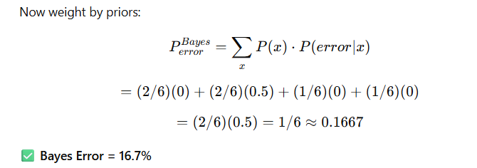

KNN Error with k=3

We classify each sample using majority vote among 3 nearest neighbors (excluding self).

Example classifications:

Red (Apple): Nearest 3 = (Red A, Green A, Green B) → Majority = Apple ✅ Correct
Green (Apple): Nearest 3 = (Green B, Red A, Orange B) → Majority = (2 Bananas, 1 Apple) → Predicted Banana ❌ Error
Green (Banana): Nearest 3 = (Green A, Red A, Orange B) → Majority = Apple ❌ Error
Orange (Banana): Nearest 3 = (Yellow B, Green A, Green B) → Majority = Banana ✅ Correct
Yellow (Banana): Nearest 3 = (Orange B, Green A, Green B) → Majority = Banana ✅ Correct

Total errors = 2/6 = 33.3%

k=3 Error = 33.3%
Bayes Error = 16.7%

